Measuring myelin protein expression levels with a MeCP2 knockdown in oligodendrocytes
Rachel Siefring

Introduction
Cases of the autism spectrum disorder (ASD) are increasing, with one in 68 children being diagnosed with some form of the disorder [1]. ASD covers a broad spectrum of neurodevelopmental disorders which are based on a child’s social interaction and communication, as well as cognitive functioning. Although the manifestation of ASD varies from child to child, most children have a barrier in communication and exhibit specific interests and behaviors. Identification of specific syndromes within ASD depends on the severity of a child’s behaviors and symptoms, as well as genetic factors. Symptoms of ASD start to exhibit themselves during the first few years of life, a critical period of brain development. [3, 5]
One particular syndrome within ASD, Rett syndrome (RTT), add something about the RTT phenotype. RTT has been associated with a mutation in the methyl-CpG-binding protein 2 (MeCP2) [2]. MeCP2 is involved in the expression of brain-derived neurotrophic factor (BDNF), an important protein in axon maturation during neurodevelopment [6]. Specifically, MeCP2 acts as both an activator and repressor of transcription [4, 5, 8, 9]. Generally, DNA methylation of cytosines results in the repression of a gene (source??). In a similar manner, MeCP2 binds to methylated cytosines within the promoter region of BDNF. Additionally, histone deacetylase (HDAC) and histone methyltransferase (HMT) proteins will also bind to the DNA, winding it into a tighter chromatin structure (see Figure 1). [9, 8, 4] Additionally, MeCP2 acts as an activator of BDNF transcription (see Figure 2). An increase in Ca²⁺ concentration results in the phosphorylation of MeCP2. Phosphorylated MeCP2 turns off the gene silencing complex, making MeCP2 an activator [9, 4].
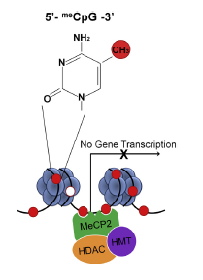
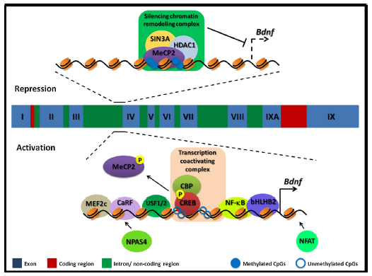
Because of its role in the expression of BDNF, research about MeCP2 has mainly focused on its role in neuronal and axonal development. However, a few researchers have begun exploring the role of MeCP2 in the glial cells of the human nervous system, specifically oligodendrocytes [13, 6]. Only found in the central nervous system (CNS), oligodendrocytes are glial cells which produce myelin for certain neuronal axons. Myelin is essential for proper conduction of signals throughout the CNS. During early development, oligodendrocytes undergo a distinct sequence of developmental events, allowing myelination to occur properly. [14] These cells express a whole host of proteins during development and myelination, including proteolipid protein (PLP), myelin basic protein (MBP), myelin-associated glycoprotein (MAG), 2', 3'-cyclic nucleotide 3'-phosphodiesterase (CNPase), and cell surface proteoglycan (NG2) [14, 15]. Figure
Figure 1: Modified Figure 1 from Karpova, 2014, paper. Methylated cytosines in the DNA sequence allow MeCP2 to bind, resulting in no transcription of BDNF.
Figure 2: Figure 2 of Cortes-Mendoza, 2013. The top panel shows MeCP2 acting as a repressor of the BDNF gene. The bottom panel shows the phosphorylated MeCP2 acting as an activator of the BDNF gene.
Using transgenic knockout rats, Vora et al (2014) compared expression levels of myelin genes from two groups of mice: mice with a truncated MeCP2 gene and mice with normal MeCP2. mRNA was isolated from both groups and quantitated using quantitative real-time reverse transcription polymerase chain reaction (qT-PCR). Using specific enzymes, including polymerases, qRT-PCR is a method which allows one to amplify a specific gene simply from using specific enzymes, including polymerases. Overall, the various expression levels showed increased expression of myelin proteins. Vora et al discovered a 2.38 fold difference between the two different rat groups expression of myelin basic protein (MBP) in the corpus callosum. Additionally, they found a 4.59 fold difference between the two groups in myelin-associated glycoprotein (MAG) in the corpus callosum. In both instances, the truncated MeCP2 rats were seen to have an upregulation in myelin genes.
Vora et al studied the role of MeCP2 in the context of the entire rat brain. Although differences in myelin genes were found, these differences do not necessarily apply to oligodendrocytes and their singular role in myelin formation and development. While Vora et al saw an upregulation of myelin proteins, other researchers have seen different results. Using knockout and truncated MeCP2 mice, Nguyen et al (2013) saw minor differences in the expression of MBP. Nevertheless, the involvement of MeCP2 in oligodendrocytes is still poorly understood. I propose that the effect of MeCP2 on myelin proteins be studied in vitro, by use of oligodendrocyte cultures. Specifically, I will study the effect of a MeCP2 knockdown in oligodendrocyte cultures.
Experiment
Using previously described methods [10], oligodendrocytes will be isolated from the cerebral hemispheres and cerbellum of rats of differing ages: 4, 11, and 21 days. These time points have been previously shown to be important time points in the development of oligodendrocytes. These cells will be placed in culture. In order to be used for this experiment, the cell cultures will need to be 80% confluent. In other words, 80% of the cultured cells should be touching each other in order to transfect as many cells as possible. The cells will then be divided into two different groups: the control and the siRNA knockdown method. After being transfected for six hours, protein expression will be measured using western blot analysis.
Central to this experiment is the MeCP2 knockdown via siRNA. siRNA consists of a synthesized, double-stranded RNA sequence that matches a 21 nucleotide sequence on the expected mRNA strand. After being transfected into the cells, the siRNA binds to the mRNA, thus prohibiting translation of the MeCP2 gene and degrading the mRNA (see Figure 3) [12]. Currently, the best method for applying siRNA is stable transfection, which uses transcribed plasmids as the siRNA segment [16, 18]. However, due to the low survival rate of oligodendrocyte cultures, other siRNA application methods will be used in this experiment [17].
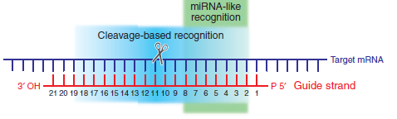
siRNA will be acquired from Sigma-Aldrich using the following methods. First, a database search will be completed to find the best MeCP2 siRNA method. Additionally, a thorough search of the literature will be completed in order to obtain the best MeCP2 siRNA sequence for this experiment. [18] Based on these search methods, a few good MeCP2 siRNA candidate sequences will be sent to Sigma-Aldrich for synthesis. Upon receiving the synthesized siRNA, the siRNA will be applied to the oligodendrocyte cultures via the GeneJammer Transfection Reagent using previously described methods from Saini et al (2005). The cultures will be transfected, with siRNA impeding the cells, for six hours. Additionally, the control cell cultures will be transfected with a scrambled siRNA sequence, to ensure that cell death in the culture is not the result of transfection. [11]
Figure 3: Figure 2 from Pei et al (2006) showing the binding the siRNA (guide strand) to the target mRNA.
If all has gone well at this point, myelin protein expression will be measured using western blot analysis and immunocytochemistry. Cell lysates from the cerebral hemispheres and the cerebellum will be generated [11, 13]. Categorized by age group and siRNA transfection sequence, each lysate will be applied with the following antibodies will be applied to the lysates: anti-MeCP2, anti-MBP, anti-MAG, and anti-β-actin (the control) [13]. If these proteins exist in the lysate, the antibodies will bind. This antibody-treated lysate will then be applied to sodium dodecyl sulfate polyacrylamide gel electrophoresis (SDS-PAGE), permitting the concentrations of each protein to be seen (similar to Figure 4).
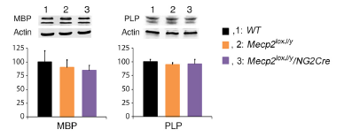
Discussion
Figure 4: Figure 7A of Nguyen et al (2013) showing the western blots of MBP and proteolipid protein (PLP).
Several problems could come up during this experiment. Isolating oligodendrocytes from the corpus callosum of a young rat brain is incredibly difficult due to the small size of postnatal rats. Additionally the potential number of isolated cells is very small. Thus, the results may not provide enough support or necessary information. Additionally, other tissue and cells which might implement MeCP2 are not being measured in this experiment.
Western blot methods although widely accepted by the neurobiology community, are qualitative results, not quantitative results. Thus, extrapolation of these results in a broad sense may be impractical. Also, the results from this experiment will be different to compare with the results from previous experiments, such as Vora et al, and Nguyen et al. These two experiments used Rett syndrome mouse models, with Vora et al measuring myelin gene expression levels. This experiment will be measuring protein expression instead of gene expression. Even though Nguyen et al used western blot and immunocytochemistry methods, comparison of results will be difficult.
Nonetheless, this experiment will further our scientific understanding of oligodendrocytes and their relationship with MeCP2.

References
- Bhat, S., et al. (2014). Autism: cause factors, early diagnosis, and therapies. Reviews in the Neurosciences. De Gruyter. 25(6): 841-850.
- Amir, R. et al. (1999). Rett syndrome is caused by mutations in X-linked MECP2, encoding methyl-CpG-binding protein 2. Nature Genetics, 23: 185-188.
- Kleijer, K., Schmeisser, M., Krueger, D., Boeckers, T., Scheiffele, P., Bourgeron, T., Brose, N., and J. Burbach. 2014. Neurobiology of autism gene products: towards pathogenesis and drug targets. Psychopharmacology. 231: 1037-1062.
- Chahrour, M., et al. (2008). MeCP2, a key contributor to neurological disease, activates and represses transcription. Science, 320: 1224-1229.
- Ebert, D. & M. Greenberg. (2013). Activity-dependent neuronal signalling and autism spectrum disorder. Nature, 493: 327-337.
- Vora, P., et al. (2010). A novel transcriptional regulator of myelin gene expression: implications for neurodevelopmental disorders. Lippincott Williams & Wilkins, 0959-4965: 917-921.
- Zeidán-Chuliá, F., et al. (2014). The glial perspective of autism spectrum disorders. Neuroscience and Biobehavioral Reviews, 38: 160-172.
- Karpova, N. (2014). Role of BDNF epigenetics in activity-dependent neuronal plasticity. Neuropharmacology, 76: 709-718.
- Cortes-Mendoza, J., et al. (2013). Shaping synaptic plasticity: the role of activity-mediated epigenetic regulation on gene transcription. International Journal of Developmental Neuroscience. 31: 359-369.
- Sato-Bigbee, C., et al. (1999). Different neuroligands and signal transduction pathways stimulate CREB phosphorylation at specific developmental stages along oligodendrocyte differentiation. Journal of Neurochemistry, 72: 139-147.
- Saini, H., et al. (2005). Novel role of sphinogosine kinase 1 as a mediator of neurotrophin-3 action in oligodendrocyte progenitors. Journal of Neurochemistry, 95: 1298-1310.
- Shan, G. (2010). RNA interference as a gene knockdown technique. The International Journal of Biochemistry and Cell Biology, 42: 1243-1251.
- Nguyen, M., et al. (2013). Oligodendrocyte lineage cells contribute unique features to Rett Syndrome neuropathology. Neurobiology of Disease, 33(48): 18764-18774.
- Bradl, M. and H. Lassmann. (2010). Oligodendrocytes: biology and pathology. Acta Neuropathol, 119: 37-53.
- Jahn, O., Tenzer, S., and H. Werner. (2009). Myelin proteomics: molecular anatomy of the insulating sheath. Mol Neurobiol, 40: 55-72.
- Theis, M. and F. Buchbolz. (2011). MISSION esiRNA for RNAi screening. Sigma-Aldrich.
- Krueger, W., Madison, D., and S. Pfeiffer. (1998). Transient transfection of oligodendrocyte progenitors by electroporation. Neurochemical Research, 23(3): 421-426.
- Pei, Y. and T. Tuschl. (2006). On the art of identifying effective and specific siRNAs. Nature Methods, 3(9): 670-676.

